# 1.

|  |  |  |  |  |  |  |  |  |
| --- | --- | --- | --- | --- | --- | --- | --- | --- |
| orderID | userID | userName | bookID | price | quantity | payment | orderTime | orderState |
| 2016001 | 101 | 张三 | 1001 | 39 | 1 | 109 | 2016-08-01 07:56:32 | 已完成 |
| 2016001 | 101 | 张三 | 1002 | 35 | 2 | 109 | 2016-08-01 07:56:32 | 已完成 |

第一范式的每个属性是不可分割的数据项

# 2.

bookID→price

userID→userName

orderID→orderTime

orderID→orderState

orderID→payment

(orderID,bookID) →quantity

orderID→userID

orderID→userName

候选码(orderID,bookID)

3.

create table userOrderInfo

(

orderID int not null,

userID int not null,

userName varchar(20) not null,

bookID int not null,

price numeric(17,2) not null,

quantity int not null,

payment numeric(17,2),

orderTime datetime not null,

orderState varchar(20) check(orderState = '未提交' or orderState = '已提交'

or orderState = '已支付' or orderState = '已完成')

primary key(orderID,bookID)

)

insert into userOrderInfo values(2016001,101,'张三',1001,39,1,109,'2016-08-01 07:56:32','已完成')

insert into userOrderInfo values(2016001,101,'张三',1002,35,2,109,'2016-08-01 07:56:32','已完成')

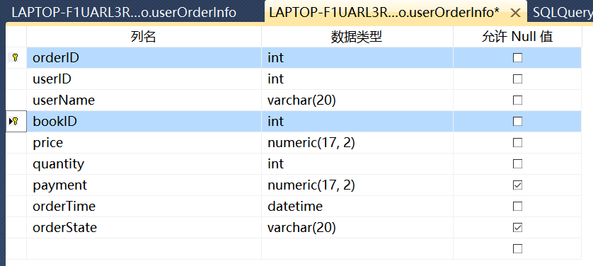

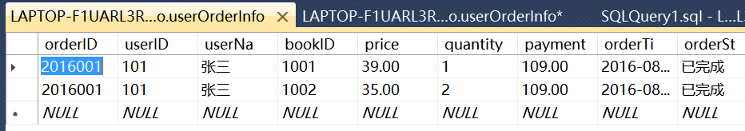

# 4.

## (1)

insert into userOrderInfo(bookID,price) values(1003,39)

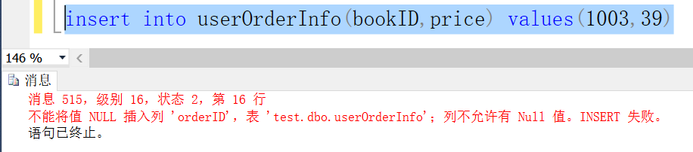

不能插入。主键orderID、userID候选码以及其他部分属性不能为空

违反实体完整性原则

## (2)

insert into userOrderInfo(userID,userName) values(102,'王丽')

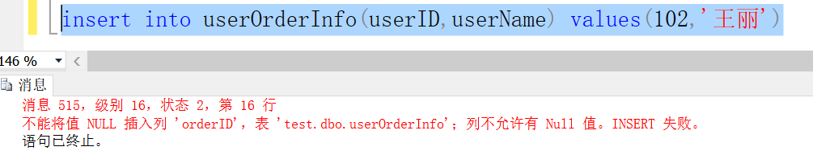

不能插入。主键orderID、bookID候选码以及其他部分属性不能为空

违反实体完整性原则

## (3)

update userOrderInfo set price = 49 where bookID = 1001

update userOrderInfo set payment = 119

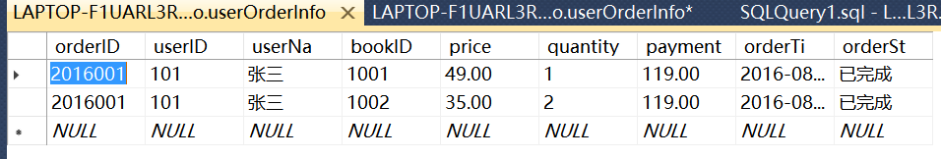

# 5.

(orderID,bookID)->price 但bookID->price

故(orderID,bookID)-P->price

所以非主属性price部分函数依赖于码，所以不符合第二范式

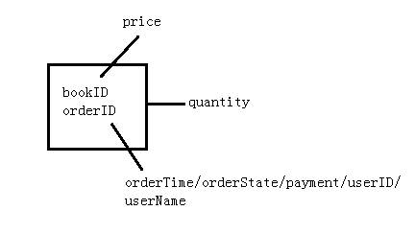

Book(bookID,price)

orderBook(orderID,bookID,quantity)

order(orderID,userID,userName,payment,orderTime,orderState)

满足第二范式

orderID-t->userName 不符合第三范式

userInfo

|  |  |
| --- | --- |
| userID | userName |
| 101 | 张三 |

orderInfo

|  |  |  |  |  |
| --- | --- | --- | --- | --- |
| orderID | userID | payment | orderTime | orderState |
| 2016001 | 101 | 109 | 2016-08-01 07:56:32 | 已完成 |

orderBook

|  |  |  |
| --- | --- | --- |
| orderID | bookID | quantity |
| 2016001 | 1001 | 1 |
| 2016001 | 1002 | 2 |

book

|  |  |
| --- | --- |
| bookID | price |
| 1001 | 39 |
| 1002 | 35 |

第二范式符合第一范式，且每个非主属性都完全依赖于码

符合无损了连接性与保持了函数依赖，四个表做自然连接后与原表相等

# 6.

create table orderInfo(

orderID int primary key,

userID int foreign key references userInfo(userID),

payment numeric(17,2) null,

orderTime Datetime not null,

orderState varchar(20) check(orderState = '未提交' or orderState = '已提交'

or orderState = '已支付' or orderState = '已完成')

)

create table orderBook(

orderID int foreign key references orderInfo(orderID),

bookID int foreign key references book(BookId),

quantity int not null,

primary key(orderID,bookID)

)

create table userInfo(

userID int primary key,

userName varchar(20) not null unique

)

create table book(

bookID int primary key,

price numeric(17,2) not null

)

insert into orderInfo values(2016001,101,109,'2016-08-01 07:56:32','已完成')

insert into userInfo values(101,'张三')

insert into orderBook values(2016001,1001,1)

insert into orderBook values(2016001,1002,2)

insert into book values(1001,39)

insert into book values(1002,35)

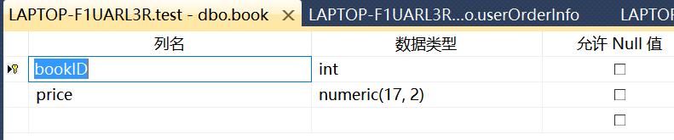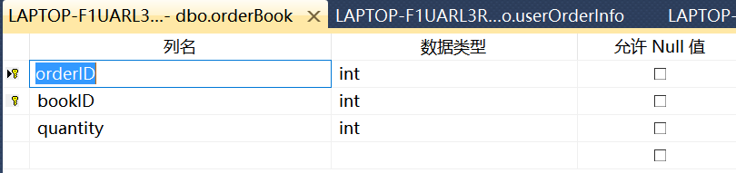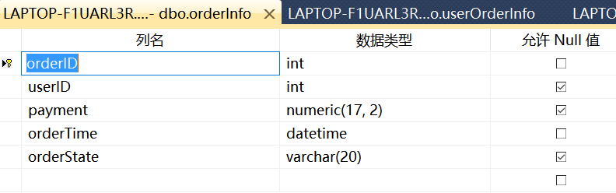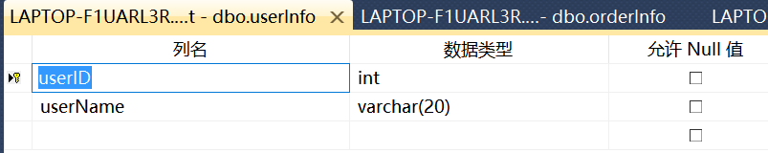

# 7.

## (1)

insert into book values(1003,39)

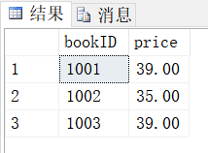

## (2)

insert into userInfo values(102,'王丽')

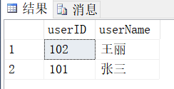

## (3)

update book set price = 49

update orderInfo set payment = (select sum(price) from book)+35

